Contents
DIRA Business 2
Committee Reports 2
2026 Recreation Grants 2
Emergency Preparedness 3
DICAN (Denman Island Climate Action Network) 4
Roads Committee 4
Pesticide Free Committee 5
Public Forum 6
Islands Trust Monthly Update 6
Food Bank Support 6
CVRD Animal Control Bylaw 6
Adjournment 7
Annex A: DICAN Climate Action Update 8
Annex B: Pesticide Free Final Report on Broom Cutting 2026 10
Annex C: Food Bank Support 12
Annex D: CVRD Animal Control Survey Results Update 13

Document History
Status | Date | Responsibility | Note
Draft 01 | 2026-06-24 | Tony Gregson | Distribution to members

Present: Stirling Fraser (President & Treasurer); Ron Wilson (Vice-Chair); Tony Gregson (Secretary); and twenty-three members.

DIRA Business
1. Call to order: The meeting was called to order at 7:10 PM.
2. Approval of Agenda: A motion to accept the agenda was approved with no changes.
3. Approval Previous Public Meeting Minutes: of: A motion to approve the minutes of AGM and Public Meeting April 13, 2026 was approved with no changes.

Committee Reports

2026 Recreation Grants
Sharon Clarke, Recreation Grant Committee chair, presented grant award decisions and their reasons. It was emphasized that recreation grants can be given only for athletics, fitness, and sport, and not activities such as reading or art. There were five applications totalling $25,934.47. The Recreation grant budget was $22,000. Four were approved.
Non-Profit Sponsor | Approved amount | Notes
DIRA - Dock Committee | $4,935.00 | Maintenance and operation of the Community Dock.
Denman Seniors & Museum Society | $4,250.00 | - $1,750 for 10 free gym memberships per year available for low income residents holding a CVRD LEAP card.  - $2,500 for badminton equipment for a Badminton Program startup to encourage a new recreational activity, open to everyone who wishes to participate.
DICES - Recreation Committee | $7,500.00 | Ongoing after school recreation program for kids aged 4 to 13, (50 at the school and 10 home schoolers).
DIRCS for DEWCK (Denman Every Wheel Concrete Kids) | $5,315.00 | - One-day event for a skatepark program, including youth workshops for safety and etiquette education, and open professionally led workshops for community engagement.  - skateboard park concept planning and design needed for future grant applications. Location on public land is confirmed and approved.
Camp Denman Society | $0 | Denied. Camp Denman Society is a member-funded Society, and is therefore ineligible for the Recreation Grant.
TOTAL | $22,000

Motion: To accept the 2026 Recreation Grants as submitted. CARRIED.
The grants must now be submitted to the CVRD for their endorsement before funds may be released.

Emergency Preparedness
Ron Wilson updated the meeting on the state of emergency preparedness on Denman.
- There is a network of neighbourhood coordinators who check on their neighbours to see how they are doing in the event of a disaster, such as fire, earthquake, or flood.
- Individual preparedness is critical to “shelter-in-place”. Most people are not prepared.
- Jenny Balke has taken over a chair of the committee. But the committee needs more members.
- There is an extensive CVRD Emergency Preparedness Plan online for the Comox Valley which offers a lot of advice for Neighbourhood Preparedness.
- The CVRD came over some years ago to help Denman Island set up its own plan, which is now out of date.


DICAN (Denman Island Climate Action Network)
Ron Wilson summarized findings from a 2026 study What Do Canadians Think About Climate Change prepared by Re.Climate. The main finding was that concern is high about climate change but it is a low priority.
See Annex A: DICAN Climate Action Update.
DICAN is also sponsoring a workshop on Sept. 27 at the Community Hall with the David Suzuki Foundation. The focus will be on what Denman is already doing about climate change and what further action we can take to save the plANET.

Roads Committee
Frank Freketich updated the meeting on the Roads Committee which has been very busy. There will be an update in the Flagstone for July.
A major meeting was convened with all the community groups concerned about roads. This included the community school, fire department, and emergency services who met with Main Road, RCMP, and MOTT. Issues that came up included:
- Dust from washboarding that gets into the school bus.
- Need to obey signs when school bus comes to a stop.
- Need to obey the speed limit of 30 kph downtown at all times, whether school children are crossing the road or not.
- Safe driving on gravel roads which requires particular skills that are unlike those needed on paved roads, a particular concern with only 36% of Denman roads paved.
A second important meeting was convened with Ministry of Transport with the Regional Manager for Vancouver Island and managers for North Island District which includes Denman. Nothing happens if you do not have the support of the Regional Manager who they felt listened carefully. The Roads Committee accepts the fact that MOTT gets round to big changes slowly, but was given to understand that Denman’s turn will come round. What we want to know is when it’s our turn.
- The biggest ask is the Big Hill which is dangerous in many ways and is beginning to slip. On that, the Roads Committee has to keep up the pressure.
- There were smaller matters where something could be done now:
  - On the conjunction with Pickles Road, the Road Committee suggested mirrors that would allow you to see what is coming, but MOTT no longer uses them. They are instead going to do a sight-line analysis.
  - A proper crosswalk downtown in front of the school.
  - Repainting of yellow lines.
  - Slumping where a new culvert was not completely installed along Lacon.
  - Late application of dust control on some roads for which there were apologies..

- There were a lot of concerns raised by members:
  - Increase in traffic along Northwest Road whipping up and down at excessive speed late at night. A lot of it seems to be island residents. One solution is to license photo radar for a time. You can also always take a photo of the license plate and the police will follow up but it is not immediate and they will not issue a fine.
  - Lack of traffic control by the BC Ferries which won’t take responsibility beyond their property for excessive lineups blocking driveways and with children and dogs in the lanes.
  - Individuals can put up speed control signage or warnings in front of their property such as a children’s bike.
  - People riding bikes along roads when they should use the Cross Island Trail.
  - Speed limits on Denman were always 50 for decades, but that changed with BC Ferries.

Pesticide Free Committee
Jennifer Veale, Chair, was not present to speak to the Final Report on broom cutting which was submitted prior to the meeting. Specifically, Jennifer hoped to propose a subsidy program for private property owners who may be unable to remove broom themselves.
SEE Annex B Pesticide Free Final Report on Broom Cutting 2026.

Public Forum

Islands Trust Monthly Update
Trustee Sam Borthwick reported on the annual review of agreements between the Islands Trust and the CVRD, and a general update on what is happening in the community.
- Ther review of protocols checks to see they are all up to date and reference the right ministries.
- The CVRD has introduced a septic maintenance rebate program for up to $7,500
- On Hornby, the CVRD has a contract to process composting toilet residuals, but there has not been much uptake, though the contract has been extended in the hopes of more interest. It is too expensive to process the residuals on island.
- The Graham Lake Water System referendum is on July 10th.

Food Bank Support
Ron Wilson updated the meeting on the need for ongoing support for the Foodbank with a letter from Gracie Macdonald.
SEE Annex C: Food Bank Support

CVRD Animal Control Bylaw
Ron Wilson reported that the CVRD has voted to support the Tier 2 option for enforcement as the preferred option from 348 survey responses.
- Licensing (of dogs) and complaint documentation
- Animal Control officer to travel to island for serious incidents that cannot be resolved remotely.
- No regular patrol presence. Attendance would be only for specific incidents.
- Local arrangements for temporary containment until the animal can be returned to its owner or retrieved.
- The animal control bylaw will be on the October 17th ballot.
- Estimated cost of $20 per year for an average household.
- SEE Annex D Update on CVRD Animal Control Bylaw

Adjournment
A motion to adjourn was carried at 8:23 PM.

Next Meeting
August 10th, 2026 7:30 PM Back Hall

Annex A: DICAN Climate Action Update
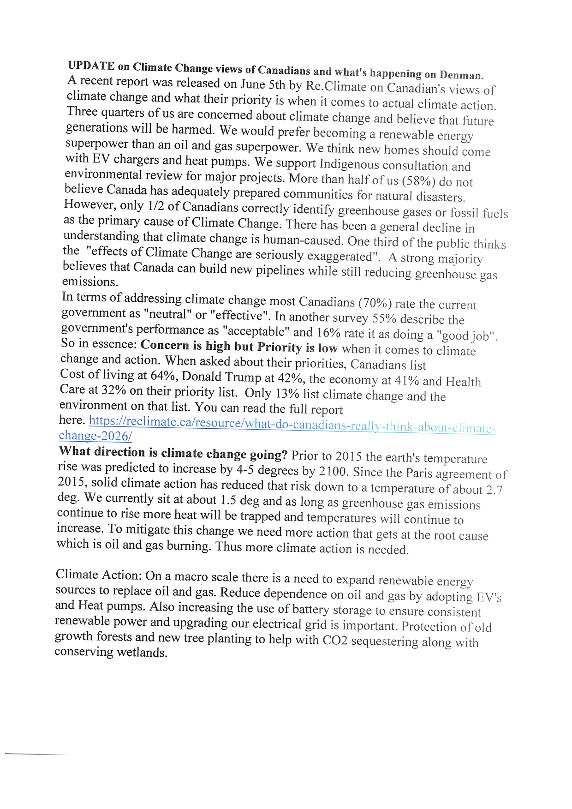
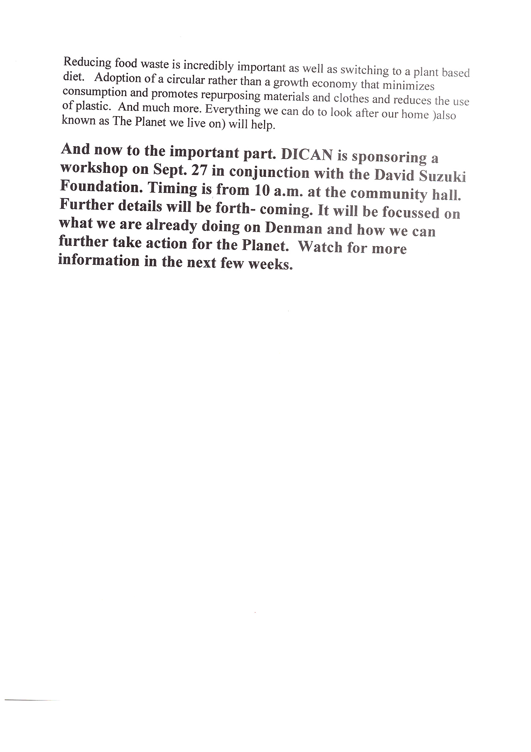

Annex B: Pesticide Free Final Report on Broom Cutting 2026
Pesticide Free Committee: Broom Cutting 2026
2026 Available Funds

Prior year balance 1,049.51
Municipal /Regional funding 3,300.00

Total funds 4,349.51
Requested and Expected Funds 3000.00
____________________________________________________________________________________
Expected Total funds 7,349.51

Expenses
Contractor labour $6006.25
Denman Market educational booth 100.00 Grapevine broom cutter ad 25.89 Thank You Gift Anne Page 185.08

Total Spent | $6,317.22
DIRA approved overspend | $1,967.71
Paid Cutting Hours | 240.25
Paid broom cutters | 5
Volunteer Cutting Hours | 27
Volunteer cutters | 8

Scotch Broom removed on: Hilberry, Creekside, Central, Owl, Lacon, Wren, Denman, Northwest

Hauling: The contractor arranged to haul had a medical issue. I will haul as soon as I can get to it
Discussion Item:

Donations: I have been offered a $3000.00 donation towards cutting broom.
There is need for a subsidy for broom cutting on private property.
This donation could be used to subsidise older, infirm or overwhelmed citizens that have quantities of broom on their property that for whatever reason are unable to tackle.
I understand that insurance is an issue for contracted labour on private property.
I’d like some feedback on this idea as the way that I see it, as long as we are not tackling broom on private or park property, we will not resolve the problem.

Annex C: Food Bank Support
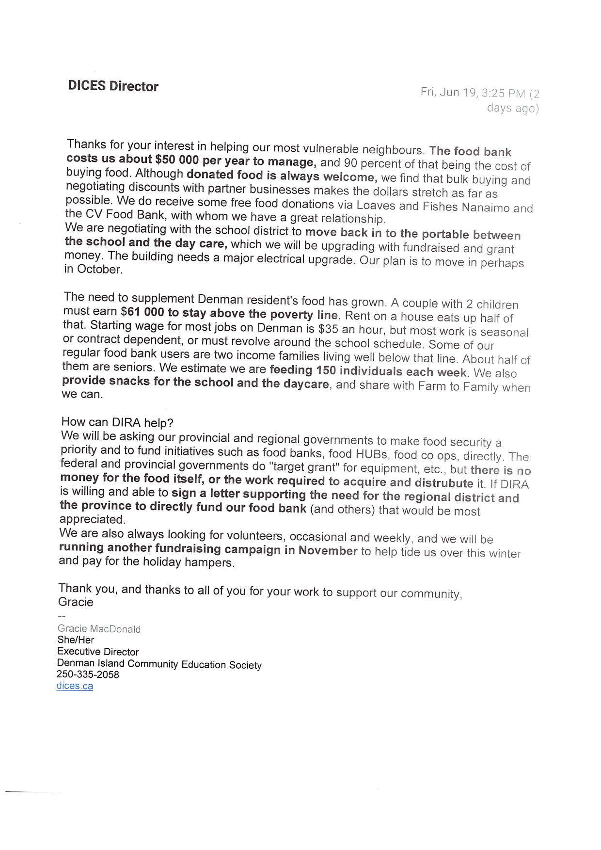

Annex D: CVRD Animal Control Survey Results Update
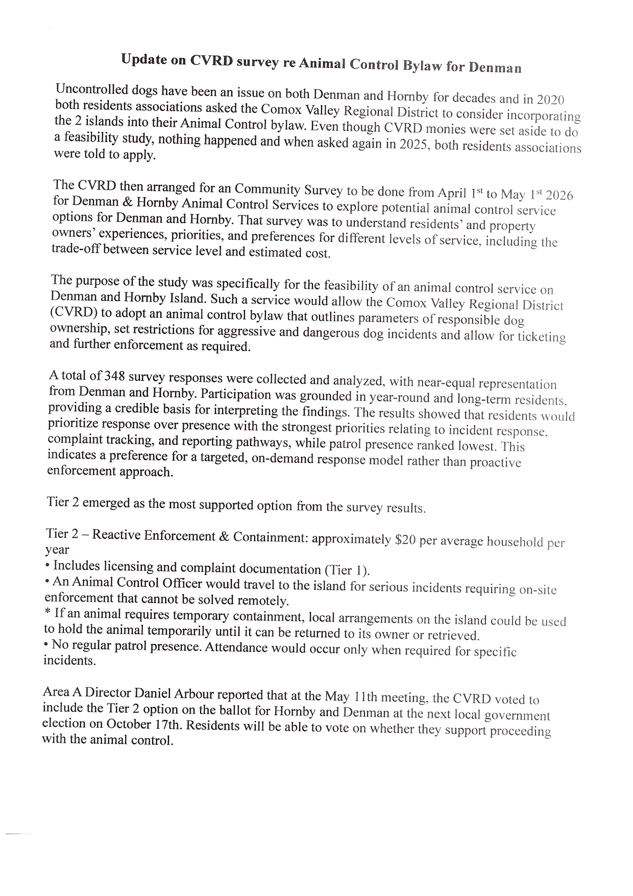

The LEAP program (Leisure for Everyone Accessibility Program) is a regional initiative of the CVRD designed to remove financial barriers to recreation. It provides eligible low-income residents with subsidized or free access to participating local government recreation facilities. DSMS honours LEAP program eligibility by waiving Fitness Centre membership fees for 10 Denman applicants each year who hold a CVRD issued LEAP card.

